# 

# **COVER PAGE**

**Microsoft Word Practice Assignment**

**A Comprehensive Document**

**NEHA FAISAL**

**20252-37711**

**BACHELOR OF STATS & BUS ANALYTICS**

**03/07/2025**

**TABLE OF CONTENTS**

Table of Contents

**COVER PAGE** 1

**TIMETABLE** 3

**MARKSHEET OF INTERMEDIATE** 4

**NEWSPAPER ARTICLE** 5

# **TIMETABLE**

|  |  |  |  |  |  |
| --- | --- | --- | --- | --- | --- |
|  | **1st Class**  **9:00 AM-10:00 AM** | **2nd Class**  **10:00 AM - 11:00 AM** | **3rd Class**  **11:00 AM - 12:00 PM** | **4th Class**  **12:00 PM - 1:00 PM** | **5th Class**  **1:00 PM - 2:00 PM** |
| MON | English | Math | Science | Physics | Urdu |
| TUE | PST | ICT | Sociology | History | Chemistry |
| WED | English | Math | Science | Physics | Urdu |
| THURS | PST | ICT | Sociology | History | Chemistry |
| FRI | Islamiyat | Islamiyat | ICT Lab | - | - |
| SAT | WEEKEND BREAK | | | | |
| SUN | WEEKEND BREAK | | | | |

# **MARKSHEET OF INTERMEDIATE**

**BOARD OF INTERMEDIATE EDUCATION**

HSC PART I -(INTERMEDIATE EXAMINATION) (ANNUAL 2024)

**Statement of Marks**

Marks Sheet No. 00231650-2

Group PRE MEDICAL

Roll No. 150277

**Enrolment /Registration No.** KCK/SM/E-0028/2024

**Name** NEHAFAISAL

Father’s Name MUHAMMAD FAISAL QURESHI

College /Private International College

|  |  |  |  |  |  |  |
| --- | --- | --- | --- | --- | --- | --- |
| **Subject** | **Part I Marks** | | | | **%** | **Remarks** |
| **Max** | | **Secured** | |
| **Th.** | **Pr.** | **Th.** | **Pr.** |
| **Urdu** | 100 | - | 95 | - | 95 | Pass |
| **English** | 100 | - | 95 | - | 95 | Pass |
| **Islamiyat** | 95 | - | 95 | - | 100 | Pass |
| **Chemistry** | 85 | 15 | 46 | 15 | 61 | Pass |
| **Physics** | 85 | 15 | 70 | 14 | 84 | Pass |
| **Biology** | 85 | 15 | 63 | 13 | 76 | Pass |
| **TOTAL** | **Max Marks** | | **Obtained Marks** | | **Passed Papers %** | **Grade** |
| 550 | | 506 | | 92 | Pass |
| **In Words** | Five Hundred Six Only | | | | | |

E. & O.E.

____________________________ ____________________________

**Prepared by IT Department CONTROLLER OF EXAMINATIONS**

**Date: December 15, 2024**

# **NEWSPAPER ARTICLE**

**DAILY PAKISTAN**

**Pakistan’s Massive Tree Plantation Drive Aims to Combat Climate Change**

**By Neha Faisal**

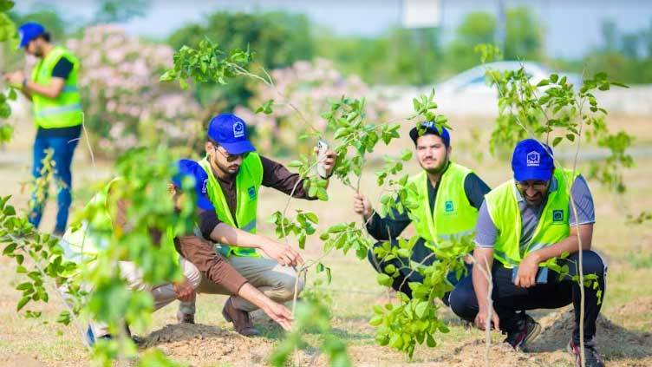

**Alkhidmat Foundation launches massive plantation drive**

*Pakistan has launched an ambitious tree plantation campaign to tackle climate change and reduce environmental pollution. The initiative, called the* ***"Ten Billion Tree Tsunami,"*** *is part of a nationwide effort to restore forests, improve air quality, and protect the environment. Over the next few years, billions of trees will be planted across the country to create a greener and healthier Pakistan.*

*Students, volunteers, and environmental activists have actively participated in the project by planting trees in schools, parks, and other public areas. This effort is expected to lower temperatures, reduce the risk of floods, and prevent soil erosion, especially in urban areas like Karachi and Lahore, where climate change has led to extreme weather conditions. Experts believe that increasing greenery will also provide much-needed shade and improve biodiversity.*

*“As citizens, we all have a role to play in protecting our environment,” said Asad Mehmood, a student volunteer. “By planting trees, we can make a real difference for future generations.” The government has also encouraged people to plant trees in their homes and communities, ensuring that Pakistan moves toward a more sustainable and eco-friendly future*